

Font for the logo Audiowide.

Color number in creating logo was use black code #000000

Color number of background was #A0DD9F

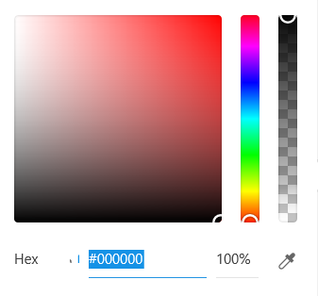 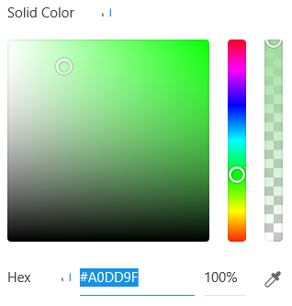

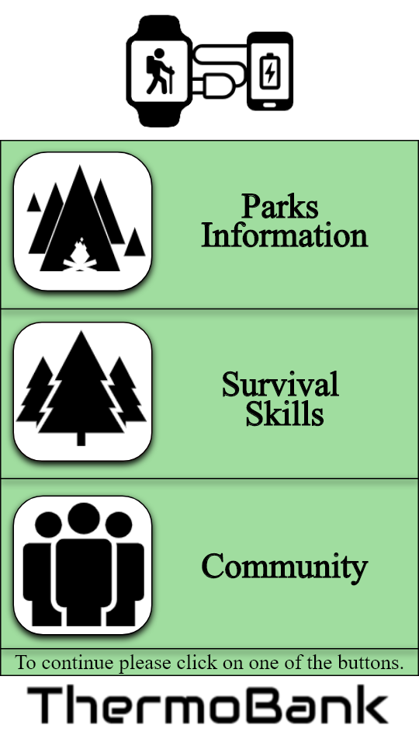

Font for the of the buttons words bold Time New Romans.

The action line To continue please click… Time New Romans

Color number in creating logo for buttons, background of name company and logo was use white code #FFFFFF

Color number of background was #A0DD9F

 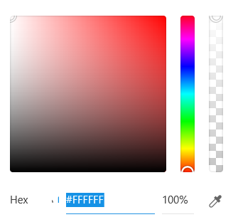

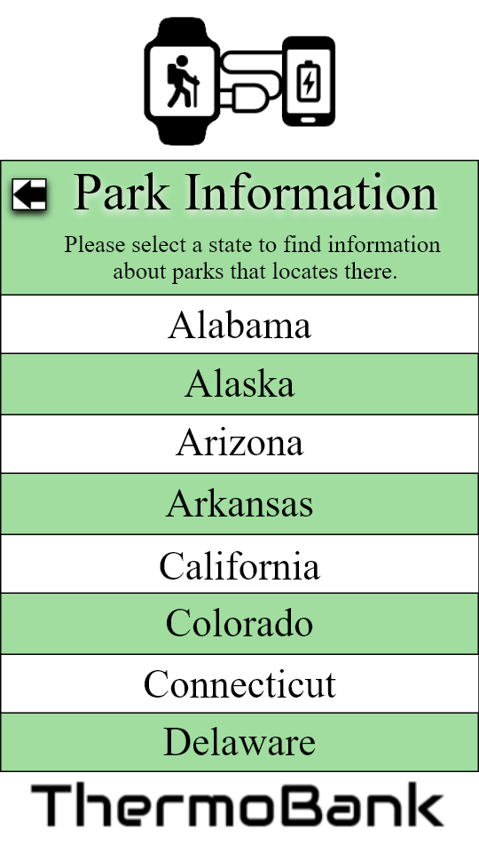

Font for the of the words Time New Romans.

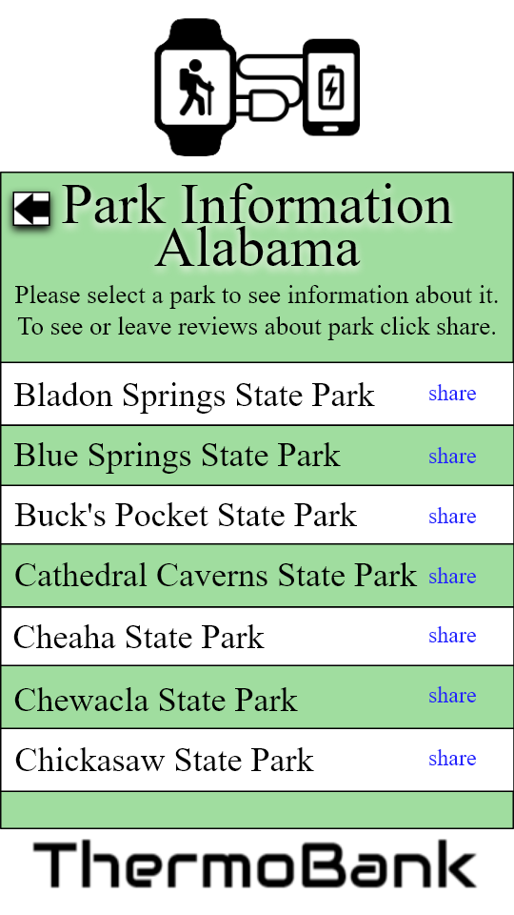 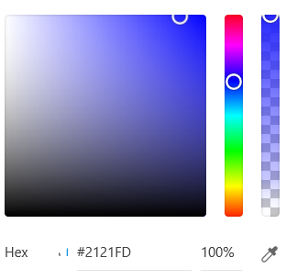

Font for words Time New Romans.

Share color code is #2121FD



Font for the of the buttons words Rockwell.

Font for the of the words Time New Romans.

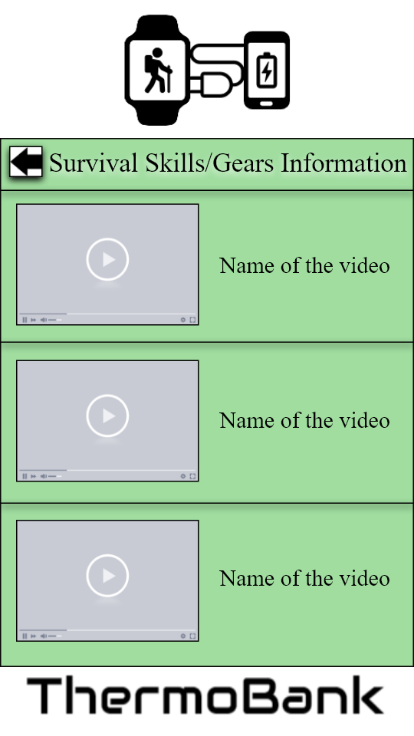

Font for the of the words Time New Romans.

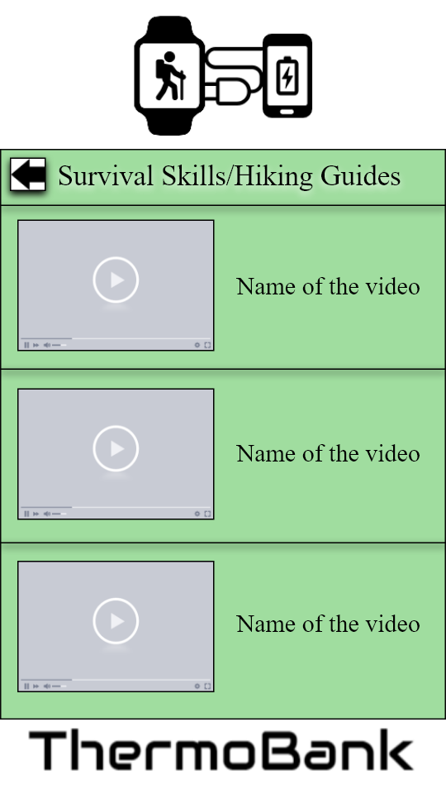

Font for the of the words Time New Romans.

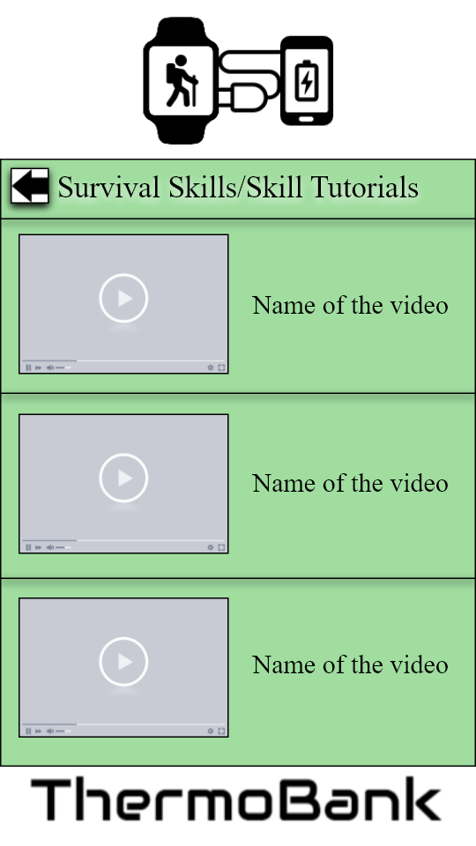

Font for the of the words Time New Romans.

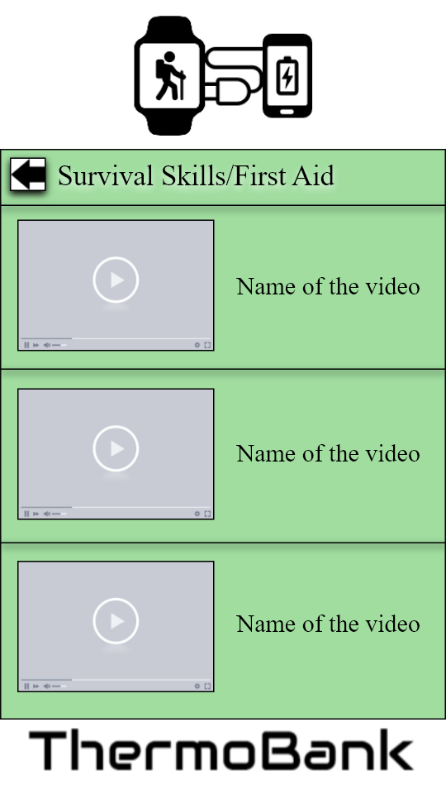

Font for the of the words Time New Romans.



Font for the of the words Time New Romans.

Font for the of the buttons words Rockwell.

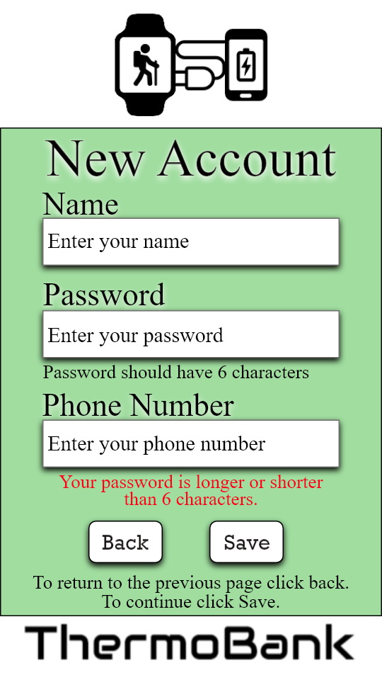

Font for the of the words Time New Romans.

Font for the of the buttons words Rockwell.

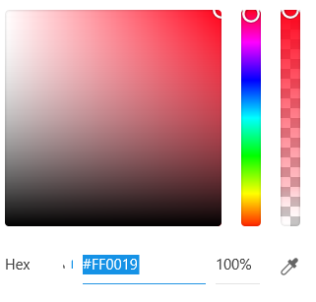

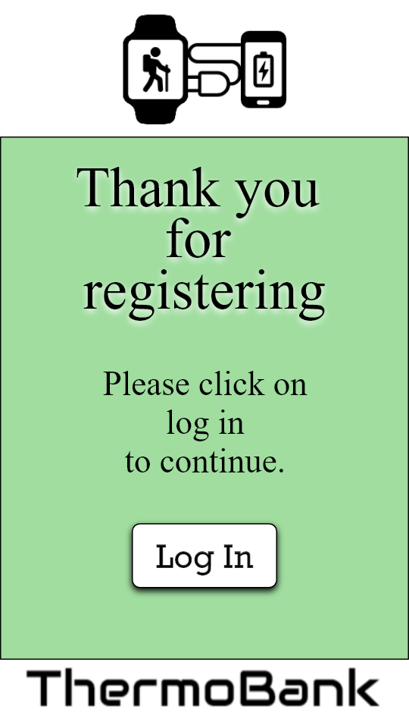

Font for the of the words Time New Romans.

Font for the of the buttons words Rockwell.

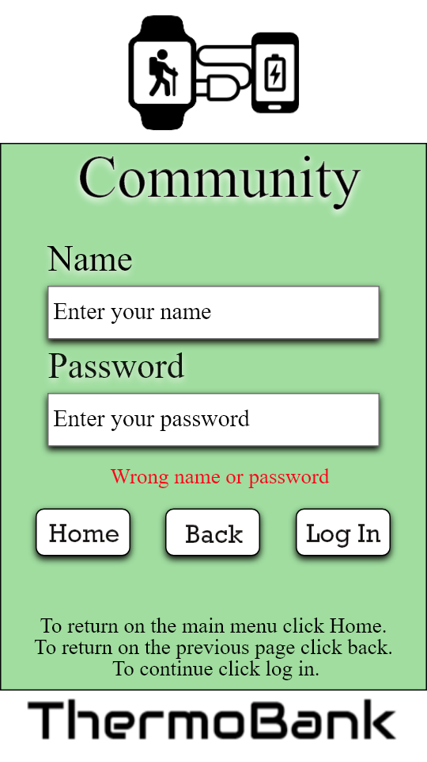

Font for the of the words Time New Romans.

Font for the of the buttons words Rockwell.



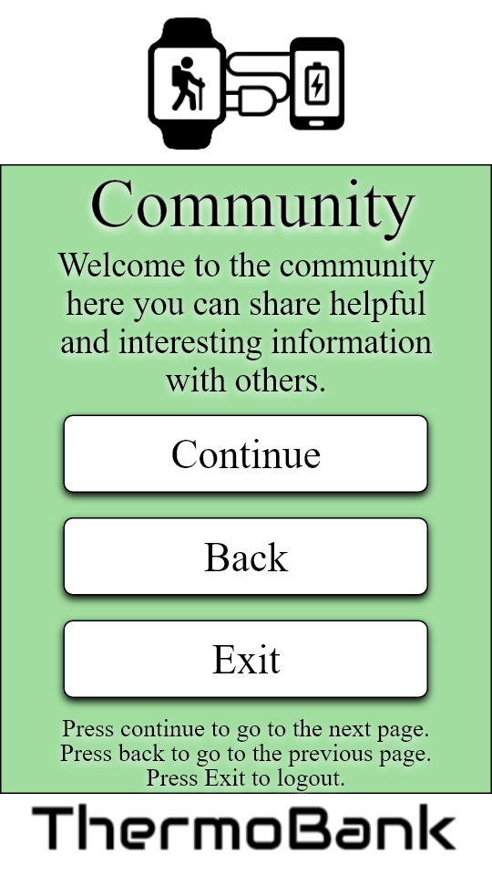

Font of everything is Time New Romans.

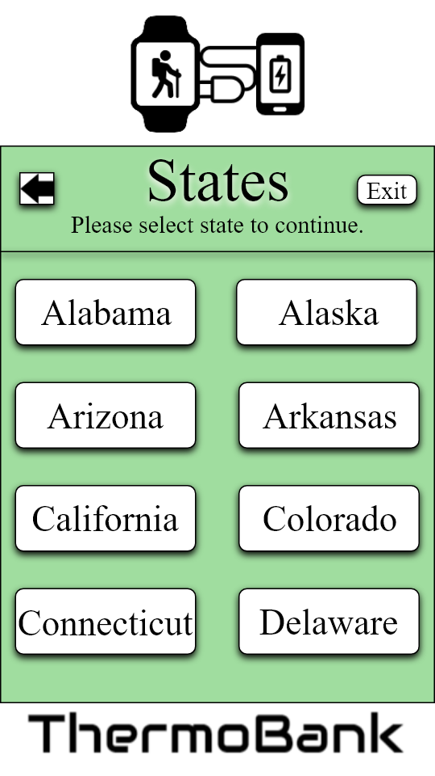

Font of everything is Time New Romans.

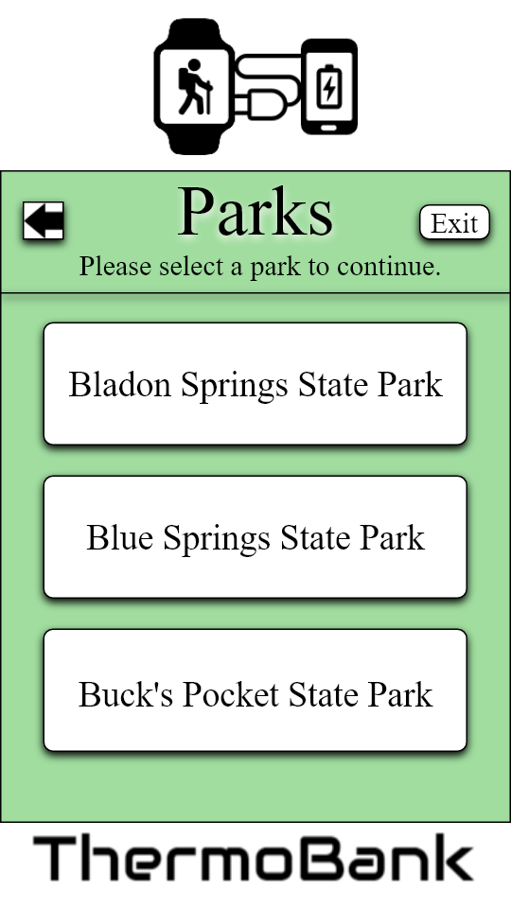

Font of everything is Time New Romans.

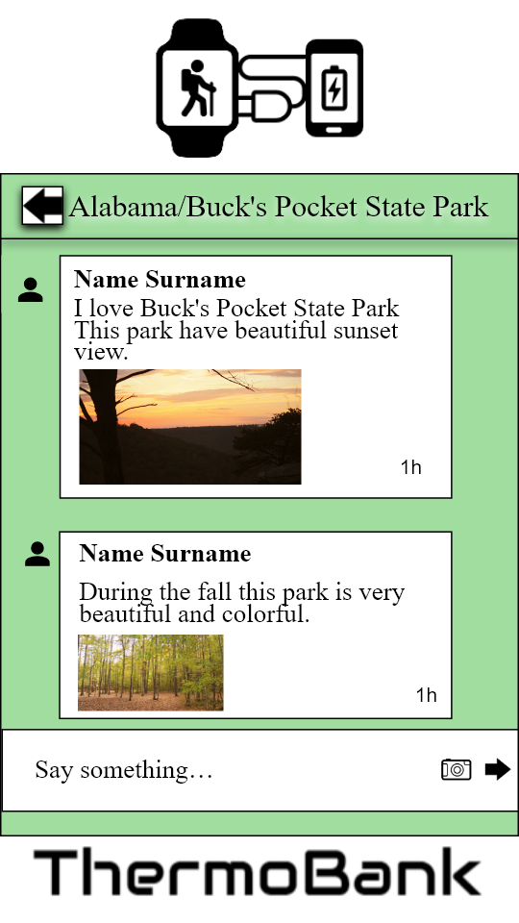

Font of everything is Time New Romans.